Shell mold casting or shell molding is a metal casting process in manufacturing industry in which the mold is a thin hardened shell of sand and thermosetting resin binder backed up by some other material.

Shell mold casting is particularly suitable for steel castings under 10 kg; however almost any metal that can be cast in sand can be cast with shell molding process. Also much larger parts have been manufactured with shell molding. Typical parts manufactured in industry using the shell mold casting process include cylinder heads, gears, bushings, connecting rods, camshafts and valve bodies.

The Process

The first step in the shell mold casting process is to manufacture the shell mold. The sand we use for the shell molding process is of a much smaller grain size than the typical greensand mold. This fine grained sand is mixed with a thermosetting resin binder. A special metal pattern is coated with a parting agent; (typically silicone), which will latter facilitate in the removal of the shell. The metal pattern is then heated to a temperature of (175 °C-370 °C) .

The sand mixture is then poured or blown over the hot casting pattern. Due to the reaction of the thermosetting resin with the hot metal pattern a thin shell forms on the surface of the pattern. The desired thickness of the shell is dependent upon the strength requirements of the mold for the particular metal casting application. A typical industrial manufacturing mold for a shell molding casting process could be 7.5mm thick. The thickness of the mold can be controlled by the length of time the sand mixture is in contact with the metal casting pattern.

The excess “loose" sand is then removed leaving the shell and pattern.

The shell and pattern are then placed in an oven for a short period of time, (minutes), which causes the shell to harden onto the casting pattern.

Once the baking phase of the manufacturing process is complete the hardened shell is separated from the casting pattern by way of ejector pins built into the pattern. It is of note that this

manufacturing technique used to create the mold in the shell molding process can also be employed to produced highly accurate fine grained mold cores for other metal casting processes.

Two of these hardened shells, each representing half the mold for the casting are assembled together either by gluing or clamping.

The manufacture of the shell mold is now complete and ready for the pouring of the metal casting. In many shell molding processes the shell mold is supported by sand or metal shot during the casting process.



SAND MiXED WSTH TIIEKMOSETTING RESIN BINDER



METAJ. PATTERN (35OK-7O0r)

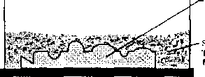

■MD'Al. FATITRN (350F-700E)

SAND MIXED W1T11 THERMOSnTING RESIN HINDER



(b)

MLTAl CAT TERN (WITO SiU.I.L)

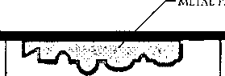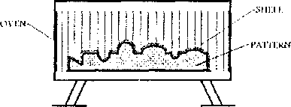

Si IEI.1. AND I’AVITRN ARE BAKED IN OVEN TO HARDEN SHU.L MOI.ll

LOT" OVER SAND MIXED WITH THERMOS DTING RESIN BINDER



(d)

(b)

MOIJJING

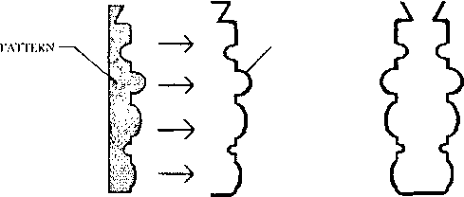

MOLDING

SliEU.

sinii.i.

(e)

(g)

**(f)**

* The internal surface of the shell mold is very smooth and rigid. This allows for an easy flow of the liquid metal through the mold cavity during the pouring of the casting, giving castings very good surface finish. Shell Mold Casting enables the manufacture of complex parts with thin sections and smaller projections than green sand molds.
* Manufacturing with the shell mold casting process also imparts high dimensional accuracy. Tolerances of 0.25mm are possible. Further machining is usually unnecessary when casting by this process.
* Shell sand molds are less permeable than green sand molds and binder may produce a large volume of gas as it contacts the molten metal being poured for the casting. For these reasons shell molds should be well ventilated.
* The expense of shell mold casting is increased by the cost of the thermosetting resin binder, but decreased by the fact that only a small percentage of sand is used compared to other sand casting processes.
* Shell mold casting processes are easily automated
* The special metal patterns needed for shell mold casting are expensive, making it a less desirable process for short runs. However manufacturing by shell casting may be economical for large batch production.

Investment casting is a manufacturing process in which a wax pattern is coated with a refractory ceramic material. Once the ceramic material is hardened its internal geometry takes the shape of the casting. The wax is melted out and molten metal is poured into the cavity where the wax pattern was. The metal solidifies within the ceramic mold and then the metal casting is broken out. This manufacturing technique is also known as the lost wax process. Parts manufactured in industry by this process include dental fixtures, gears, cams, ratchets, jewelry, turbine blades, machinery components and other parts of complex geometry.

The Process

The first step in investment casting is to manufacture the wax pattern for the process. The pattern for this process may also be made from plastic; however it is often made of wax since it will melt out easily and wax can be reused.

Since the pattern is destroyed in the process one will be needed for each casting to be made. When producing parts in any quantity a mold from which to manufacture patterns will be desired. The mold to create wax patterns may be cast or machined. The size of this master die must be carefully calculated.

It must take into consideration shrinkage of wax, shrinkage of the ceramic material invested over the wax pattern, and shrinkage of the metal casting. It may take some trial and error to get just the right size, therefore these molds can be expensive.

Since the mold does not need to be opened castings of very complex geometry can be manufactured.

Several wax patterns may be combined for a single casting. Or as often the case, many wax patterns may be connected and poured together producing many castings in a single process. This is done by attaching the wax patterns to a wax bar, the bar serves as a central sprue.

A ceramic pouring cup is attached to the end of the bar. This arrangement is called a tree, denoting the similarity of casting patterns on the central runner beam to branches on a tree.

The casting pattern is then dipped in a refractory slurry whose composition includes extremely fine grained silica, water, and binders. A ceramic layer is obtained over the surface of the pattern. The pattern is then repeatedly dipped into the slurry to increase the thickness of the ceramic coat. In some cases the pattern may be placed in a flask and the ceramic slurry poured over it.

Squeeze casting

Squeeze casting as liquid-metal forging, is a process by which molten metal solidifies under pressure within closed dies positioned between the plates of a hydraulic press.

The applied pressure and instant contact of the molten metal with the die surface produce a rapid heat transfer condition that yields a pore-free fine-grain casting with mechanical properties approaching those of a wrought product.

The squeeze casting process is easily automated to produce near-net to net shape high-quality components.

Aluminum, magnesium, and copper alloy components are readily manufactured using this process. .

The squeeze casting process, combining the advantages of the casting and forging processes, has been widely used to produce quality castings.

Because of the high pressure applied during solidification, porosities caused by both gas and shrinkage can be prevented or eliminated.

The cooling rate of the casting can be increased by applying high pressure during solidification, since that contact between the casting and the die is improved by pressurization, which results in the foundation of fine-grained structures.

Squeeze casting is simple and economical, efficient in its use of raw material, and has excellent potential for automated operation at high rates of production.

The process generates the highest mechanical properties attainable in a cast product. The microstructural refinement and integrity of squeeze cast products are desirable for many critical applications.

As shown in Fig. , squeeze casting consists of entering liquid metal into a preheated, lubricated die and forging the metal while it solidifies.

The load is applied shortly after the metal begins to freeze and is maintained until the entire casting has solidified.

Casting ejection and handling are done in much the same way as in closed die forging.

There are a number of variables that are generally controlled for the soundness and quality of the castings.

**Tundish**

**Strand**

Submerged Entry Nozzle

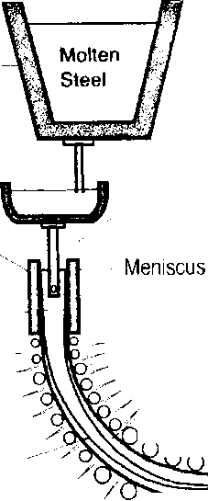

**Solid Billet**

0>*

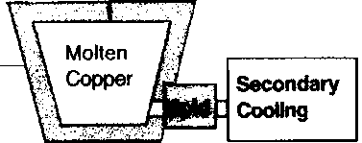

**Ladle**

**Holding**

**Furnace**

Molten

**Mold**

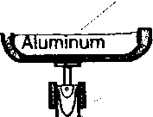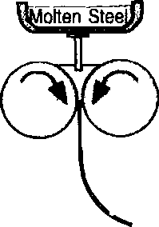

\ Liquid Pool

Spray

Cooling

Torch

Support roll Cutoff

Point/

, Solidifying /

" Shell .. . „ . . /Solid ./ Metallurgical ; stee|

•/r\L Length

Twin

Rolls

**/ Slab**

1CZI

**Solid Thin Strip**

-J;

Vertical

/O/P 0 0 0 (j Curved

Strip Casting

Horizontal

B.G. Thomas, 2000.

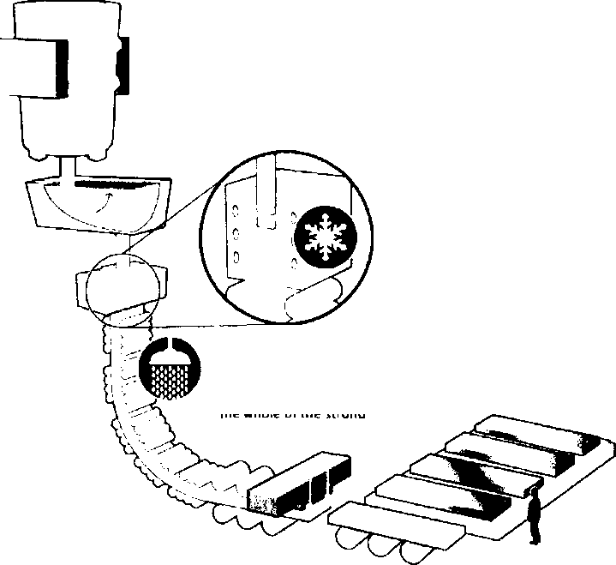

Figure 1. Various continuous casting processes

The molten steel con be tapped from the bottom of the ladle into an intermed­iate container known as the tundish. The temperature of the melt is now below 1,600'C.

Cooling continues by quenching with water aiong the whole of the strand.

The open mould consists of four water- cooled plates between which the hot steel slides. A solidified shell is formed during costing. The casting temperature is around 1,540°C

The steel is still glowing hot but has solidified all the way through when it is cut into slabs by means of oxygen lances. The temperature is 1.000X Every slab is marked before it is placed on the cooling bed.

Die Casting (Pressure Die Casting)

Die casting refers to the forcing, by pressure of molten metal into a metal die or mould. The term 'die' used in this process implies a metallic mould which is filled under pressure. In this process, metal castings with great surface detail, dimensional accuracy, and extremely thin walls can be produced. Wall thickness within castings can be manufactured as small as 0.5mm.

Die Casting Dies (Die Construction)

* Dies, or die casting tooling, are made of alloy tool steels in at least two sections, the fixed die half, or cover half, and the ejector die half, to permit removal of castings. Modern dies also may have moveable slides, cores or other sections to produce holes, threads and other desired shapes in the casting.
* Die cavities are made with great accuracy usually by machining process. Dies for both the hot and cold-chamber machines are similar in construction because there is little difference in the method of holding and operating them.
* Sprue holes in the fixed die half allow molten metal to enter the die and fill the cavity.
* The ejector half usually contains the runners (passageways) and gates (inlets) that route molten metal to the cavity.
* Vents and small overflow wells are provided on one side of a die;

o to facilitate the escape of air and

o to catch surplus metal that has passed through the die cavity.

* In spite of this provision, there is a certain amount of flash metal which is trimmed off in the finishing operation e.g., grinding or blanking (press shearing).
* Dies also include locking pins to secure the two halves, ejector pins to help remove the cast part, and openings for coolant and lubricant.
* The surface where the ejector and fixed halves of the die meet and lock is referred to as the "die parting line."
* The total projected surface area of the part being cast, measured at the die parting line, and the pressure required of the machine to inject metal into the die cavity governs the clamping force of the machine.

Characteristics of Die Metal

* Die casting dies are usually made of an alloy steel (tool steel, mold steel, or maraging steel) having the following characteristics:
* It should be dimensionally stable.
* It should have high resistance to heat.
* It should not get soldered to the cast alloy.
* It should resist erosion.
* It should have high wear resistance and toughness.

♦> Tungsten and molybdenum (good refractory qualities) used to die cast steel and cast iron

* for tin and lead alloy casting, dies are made of carbon steels without heat treatment,
* for zinc, aluminium and magnesium, dies are of heat treated low-alloy steel,

♦t* for copper-base castings, heat treated special alloy steel dies are used.

Types of Dies

There are four types of dies:

1. Single cavity to produce one component
2. Multiple cavity to produce a number of identical parts (several castings with each cycle)
3. Unit die to produce different parts at one time
4. Combination die to produce several different parts for an assembly.

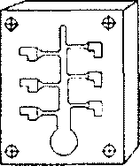

(b)MuUiple-cavUy die

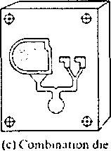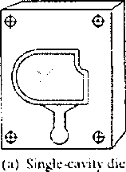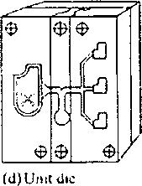

During the design of die casting dies, the following points should be kept in view in addition to the considerations given for sand casting design:

* Die casting should be so designed that the cost of flash removal is minimum.
* Artificial means of venting are essential to have sound castings free from porosity.
* The runners and risers should be so located that they facilitate the removal of the casting.
* Proper type and simplest possible shape of cores should be provided.
* Keep sections as uniform as possible. Where sections must be varied, make transitions gradual to avoid stress concentration.
* Die casting design must provide for location of ejector pins. The location of ejector pins is largely determined by the location and magnitude of metal shrinkage on die parts as metal cools in the die.
* Design die castings to minimize machining. Where machining is specified, allow sufficient metal for required cuts.
* In manufacturing industry it is of concern to keep the mold cool. Die may have special passages built into them that water is cycled through in order to keep down thermal extremes.

THE DIE CASTING CYCLE

* In the casting cycle, first the die is closed and locked. The molten metal, which is maintained by a furnace at a specified temperature, then enters the injection cylinder.
* During the injection stage of the die casting process, pressure is applied to the molten metal, which is then driven quickly through the feed system of the die while air escapes from the die through vents.
* The volume of metal must be large enough to overflow the die cavities and fill overflow wells.
* Once the cavities are filled, pressure on the metal is increased and held for a specified dwell time during which solidification takes place.
* The dies are then separated, and the part extracted, often by means of automatic machine operation.
* The open dies are then cleaned and lubricated as needed, and the casting cycle is repeated.
* The lubricant will assist in cooling down the dies as well as preventing the metal casting from sticking to the mold.
* Following extraction from the die, parts are often quenched and then trimmed to remove the runners, overflow wells and any parting-line flash that is produced.
* Subsequently, secondary machining and surface finishing operations may be performed.

Types of Die Casting Machines Hot Chamber Machine

It consists of a suitable furnace for melting and holding the metal. When the plunger is raised, it uncovers an opening or port in the chamber wall, through which the metal enters, filling the chamber.

In operation, the plunger is forced downwards pneumatically or hydraulically, closing the- opening and then forcing the confined metal up through a suitable channel and nozzle into the die. After a predetermined time, the plunger is again raised, allowing the molten metal in the channel and nozzle to drop back. The die is opened and the solidified die casting is ejected.

Metal injection speeds and pressures are controllable to suit different metals and castings. To attain uniformity and maximum speed of operation, a predetermined and automatically controlled cycle for various operations should be used. Operator is however required to remove the casting from the die, inspect and sometimes lubricate it.

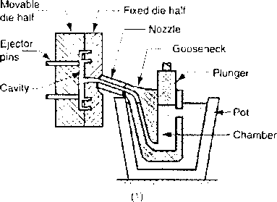

Hot-chamber machine

Limitations

Hot chamber machines are used with low-melting alloys because of:

* Machine difficulties encountered at high temperatures.
* The increased corrosion of the machine parts.
* Since many metals have an affinity for iron, only those casting alloys, which do not attack the immersed metal parts are used. Alloys of zinc, tin and lead are particularly recommended for these machines.
* Die casting of brass, aluminium and magnesium requires higher pressures and melting temperatures. Hence, a change in the melting procedure is necessary. These metals are not melted in a self-contained pot, since the life of the pot would be very short.

Cold Chamber Machine

o The molten metal is ladled from the melting pot into a pouring slot in the main pressure chamber

o A close fitting plunger is rammed forward by hand or pneumatic action. This confines the metal against the die opening and actually squirts it into the die at pressures of 400 to 1500 kg/cm2 and higher.

o Because most die castings are of thin section (usually 3 mm or less), solidification is extremely rapid. After the casting is solid, the die halves are opened and cores are withdrawn.

o High melting point alloys of aluminum, brass, copper, and aluminum-zinc are often cast in manufacturing industry using cold chamber die casting.

o The cold die casting process requires the application of more pressure than hot-chamber machines.

o Aside from the ladling procedure, the operation of the machine is the same for hot-chamber machines.

Movable^ die half

Ejector

pins

Cavity —

Fixed die half

— Ladle

3u^

Cold-chamber machine

—— Ram — Shot chamber

* Die casting is an efficient, economical process offering a broader range of shapes and components than any other manufacturing technique.
* Die casting provides complex shapes within closer tolerances than many other mass production processes. Little or no machining is required and thousands of identical castings can be produced
* Die casting produces parts that are durable and dimensionally stable.
* Thin wall castings are stronger and lighter than those possible with other casting methods.
* Die castings do not consist of separate parts welded or fastened together, the strength is that of the alloy rather than the joining process.
* Die cast parts can be produced with smooth or textured surfaces, and they are easily plated or finished with a minimum of surface preparation.
* Thin sections can be cast with good surface finish. Details can be reproduced successfully with a high degree of precision

Disadvantages of Die Casting

* High cost of the equipment and dies used requires sufficiently large quantities to compete economically with other processes. For die casting, minimum economic quantity is considered to be about 20,000.
* There is a rapid decrease in the life of the dies as the metal temperature increases.
* In some cases, there is an undesirable chilling effect on the metal.
* Metals having a high coefficient of contraction must be removed from the mould as soon as possible because of the inability of the mould to contract with the casting.
* There are certain limitations in the shape of die castings and the process is not adapted to the production of large castings. So far, the maximum size cast is 100 kg in zinc and 30 kg in aluminium.
* Die castings usually contain some porosity due to the entrapping of air.
* Die casting has, to a large extent, been limited to low-melting non-ferrous alloys. With a gradual improvement of heat-resisting metals for dies, this process can now be used for numerous alloys.

Die-Casting Alloys

The four major types of alloys that are die-cast are zinc, aluminum, magnesium, and copper-based alloys. Lead and tin are now very rarely die-cast because of their poor mechanical properties.

* Zinc base alloys

The easiest alloy to cast. Over 75% of die castings produced are the zinc base type. Zinc is economical for small parts, has a low melting point and promotes long die life.

The purest grades of commercial zinc, 99.90%, known as Special High grade, should be used, since impurities like lead, cadmium, tin cause serious casting and aging defects.

* Aluminium base alloys

Many die castings are made of aluminium. Compared to zinc alloys, however, they are slightly lower in physical properties and more difficult to die cast. Aluminum alloys have the disadvantage of requiring the use of cold-chamber machines, which usually have longer cycle times than hot-chamber machines owing to the need for a separate ladling operation. Although more expensive to operate than the air injection type, it has advantage of producing sounder castings

Some machine is designed to use metal in a semi-liquid or plastic state to permit operation at lower temperatures than those used for liquid metal. To protect the dies further from overheating, water is circulated through plates adjacent to the dies. Metal is maintained under close temperature control and is ladled by hand to the compression chamber.

* Magnesium-base Alloys

The principal die casting alloy of magnesium having good casting characteristics. The easiest alloy to machine, magnesium has an excellent strength-to-weight ratio and is the lightest alloy commonly die cast.

|  |  |  |  |  |
| --- | --- | --- | --- | --- |
| Characteristics of Die Casting Alloys | | | | |
|  | Aluminum | Brass | Magnesium | Zinc |
| Dimensional stability | Good | Excellent | Excellent | Good |
| Corrosion resistance | Good | Excellent | Fair | Fair |
| Casting ease | Good | Fair | Good | Excellent |
| Part complexity | Good | Fair | Good | Excellent |
| Dimensional accuracy | Good | Fair | Excellent | Excellent |
| Die cost | Medium | High | Medium | Low |
| Machining cost | Low | Medium | Low | Low |
| Finishing cost | Medium | Low | High | Low |

|  |  |  |  |  |
| --- | --- | --- | --- | --- |
| Processing and Production | | | | |
| Machine Types: | Aluminum | Brass | Magnesium | Zinc |
| Hot chamber (Plunger) | No | No | Yes | Yes |
| Cold chamber | Yes | Yes | Yes | Yes |
| Production range, shots/hr | 40-200 | 40-200 | 75-400 | 200-550 |
| Average tool life, no. of shots x 1000 | 125 | 20 | 200 | 500 |

Shell mold casting or shell molding is a metal casting process in manufacturing industry in which the mold is a thin hardened shell of sand and thermosetting resin binder backed up by some other material.

Shell mold casting is particularly suitable for steel castings under 10 kg; however almost any metal that can be cast in sand can be cast with shell molding process. Also much larger parts have been manufactured with shell molding. Typical parts manufactured in industry using the shell mold casting process include cylinder heads, gears, bushings, connecting rods, camshafts and valve bodies.

The Process

The first step in the shell mold casting process is to manufacture the shell mold. The sand we use for the shell molding process is of a much smaller grain size than the typical greensand mold. This fine grained sand is mixed with a thermosetting resin binder. A special metal pattern is coated with a parting agent, (typically silicone), which will latter facilitate in the removal of the shell. The metal pattern is then heated to a temperature of (175 °C-370°C) .

The sand mixture is then poured or blown over the hot casting pattern. Due to the reaction of the thermosetting resin with the hot metal pattern a thin shell forms on the surface of the pattern. The desired thickness of the shell is dependent upon the strength requirements of the mold for the particular metal casting application. A typical industrial manufacturing mold for a shell molding casting process could be 7.5mm thick. The thickness of the mold can be controlled by the length of time the sand mixture is in contact with the metal casting pattern.

The excess "loose" sand is then removed leaving the shell and pattern.

The shell and pattern are then placed in an oven for a short period of time, (minutes), which causes the shell to harden onto the casting pattern.

Once the baking phase of the manufacturing process is complete the hardened shell is separated from the casting pattern by way of ejector pins built into the pattern. It is of note that this

manufacturing technique used to create the mold in the shell molding process can also be employed to produced highly accurate fine grained mold cores for other metal casting processes.

Two of these hardened shells, each representing half the mold for the casting are assembled together either by gluing or clamping.

The manufacture of the shell mold is now complete and ready for the pouring of the metal casting. In many shell molding processes the shell mold is supported by sand or metal shot during the casting process.

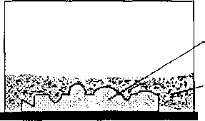

METAL PA'JT'EKN

(350K-700E)

SAND MIXED WITH TH ERMOSE1T1NG RESIN HINDER

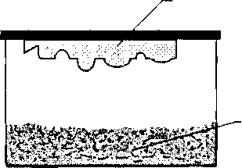

META I. PATTERN

(350E-700I)

SAND MiXEU WITH THERMOS KITING RESIN BINDER

(b)

(a)

- METAL PATTERN (Win I SI IEEE)

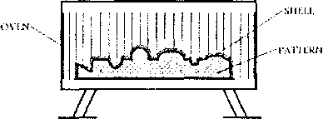

SHELL AND IWTft'RN ARK lUKI'.l) IN OVEN TO HARDEN S1IEEI, MOLD

LEIT OVER -SAND MIXED WITH TIIEKMOSETEING RESIN BINDER



(d)

**(b)**



4



MOLDING

SHELL

IWn’ERN

Mot.niNc; si nil.i.

(e)

**(g)**

**(f)**

* The internal surface of the shell mold is very smooth and rigid. This allows for an easy flow of the liquid metal through the mold cavity during the pouring of the casting, giving castings very good surface finish. Shell Mold Casting enables the manufacture of complex parts with thin sections and smaller projections than green sand molds.
* Manufacturing with the shell mold casting process also imparts high dimensional accuracy. Tolerances of 0.25mm are possible. Further machining is usually unnecessary when casting by this process.
* Shell sand molds are less permeable than green sand molds and binder may produce a large volume of gas as it contacts the molten metal being poured for the casting. For these reasons shell molds should be well ventilated.
* The expense of shell mold casting is increased by the cost of the thermosetting resin binder, but decreased by the fact that only a small percentage of sand is used compared to other sand casting processes.
* Shell mold casting processes are easily automated
* The special metal patterns needed for shell mold casting are expensive, making it a less desirable process for short runs. However manufacturing by shell casting may be economical for large batch production.

Investment casting is a manufacturing process in which a wax pattern is coated with a refractory ceramic material. Once the ceramic material is hardened its internal geometry takes the shape of the casting. The wax is melted out and molten metal is poured into the cavity where the wax pattern was. The metal solidifies within the ceramic mold and then the metal casting is broken out. This manufacturing technique is also known as the lost wax process. Parts manufactured in industry by this process include dental fixtures, gears, cams, ratchets, jewelry, turbine blades, machinery components and other parts of complex geometry.

The Process

The first step in investment casting is to manufacture the wax pattern for the process. The pattern for this process may also be made from plastic; however it is often made of wax since it will melt out easily and wax can be reused.

Since the pattern is destroyed in the process one will be needed for each casting to be made. When producing parts in any quantity a mold from which to manufacture patterns will be desired. The mold to create wax patterns may be cast or machined. The size of this master die must be carefully calculated.

It must take into consideration shrinkage of wax, shrinkage of the ceramic material invested over the wax pattern, and shrinkage of the metal casting. It may take some trial and error to get just the right size, therefore these molds can be expensive.

Since the mold does not need to be opened castings of very complex geometry can be manufactured.

Several wax patterns may be combined for a single casting. Or as often the case, many wax patterns may be connected and poured together producing many castings in a single process. This is done by attaching the wax patterns to a wax bar, the bar serves as a central sprue.

A ceramic pouring cup is attached to the end of the bar. This arrangement is called a tree, denoting the similarity of casting patterns on the central runner beam to branches on a tree.

The casting pattern is then dipped in a refractory slurry whose composition includes extremely fine grained silica, water, and binders. A ceramic layer is obtained over the surface of the pattern. The pattern is then repeatedly dipped into the slurry to increase the thickness of the ceramic coat. In some cases the pattern may be placed in a flask and the ceramic slurry poured over it.

Once the refractory coat over the pattern is thick enough it is allowed to dry in air in order to harden.

The next step in this manufacturing process is the key to investment casting. The hardened ceramic mold is turned upside down and heated to a temperature of around 90 C-175 C. This causes the wax to flow out of the mold leaving the cavity for the casting.

The ceramic mold is then heated to around 550 C-1100 C. This will further strengthen the mold, eliminate any leftover wax or contaminants, and drive out water from the mold material.

The casting is then poured while the mold is still hot. Pouring the casting while the mold is hot allows the liquid metal to flow easily through the mold cavity filling detailed and thin sections. Pouring the casting in a hot mold also gives better dimensional accuracy since the mold and casting will shrink together as they cool.

After pouring of the molten metai into the mold, the casting is allowed to set as the solidification process takes place.

The final step in this manufacturing process involves breaking the ceramic mold from the casting and cutting the parts from the tree.

Properties And Considerations Of Manufacturing By Investment Casting

* Investment Casting is a manufacturing process that allows the casting of extremely complex parts, with good surface finish.
* Very thin sections can be produced with this process. Metal castings with sections as narrow as 0.4mm have been manufactured using investment casting.
* Investment casting also allows for high dimensional accuracy. Tolerances as low as

1. 076mm have been claimed with this manufacturing process.

* Practically any metal can be investment cast. Parts manufactured by this process are generally small, but parts weighing up to 40 kg have been found suitable for this technique.
* Parts of the investment process may be automated.
* Investment casting is a complicated process and is relatively expensive.

n

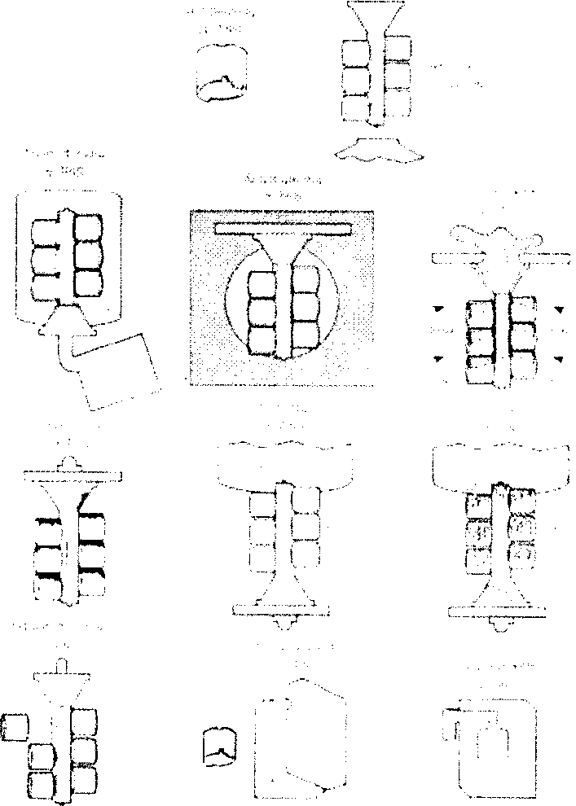

Properties and Considerations of Manufacturing by Basic Permanent Mold Casting

* Generally this manufacturing process is only suited for materials with lower melting temperatures, such as zinc, copper, magnesium, and aluminum alloys.
* Cast iron parts are also manufactured by this process but the high melting temperature of cast iron is hard on the mold.
* Steels may be cast in permanent molds made of graphite or some special refractory material.
* The mold may be cooled by water or heat fins to help the dissipation of heat during the casting process.
* Due to the need to open and close the mold to remove the work piece, part geometry is limited.
* If the semi-permanent casting method is used internal part geometry may be complex.
* Due to the nature of the mold the metal casting will solidify rapidly. This will result in a smaller grain structure producing a casting with superior mechanical properties.
* More uniform properties throughout the material of the cast part may also be observed with permanent mold casting.
* Closer dimensional accuracy as well as excellent surface finish of the part, is another advantage of this manufacturing process.
* In industrial manufacture permanent mold casting results in a lower percentage of rejects than many expendable mold processes.
* There is a limitation on the size of cast parts manufactured by this process.
* The initial setup cost are high making permanent mold casting unsuitable for small production runs.
* Permanent Mold Casting can be highly automated.
* This manufacturing process is useful in industry for high volume runs. Where once set up, it can be extremely economical with a high rate of production.

Squeeze casting

Squeeze casting as liquid-metal forging, is a process by which molten metal solidifies under pressure within closed dies positioned between the plates of a hydraulic press.

The applied pressure and instant contact of the molten metal with the die surface produce a rapid heat transfer condition that yields a pore-free fine-grain casting with mechanical properties approaching those of a wrought product.

The squeeze casting process is easily automated to produce near-net to net shape high-quality components.

Aluminum, magnesium, and copper alloy components are readily manufactured using this process. .

The squeeze casting process, combining the advantages of the casting and forging processes, has been widely used to produce quality castings.

Because of the high pressure applied during solidification, porosities caused by both gas and shrinkage can be prevented or eliminated.

The cooling rate of the casting can be increased by applying high pressure during solidification, since that contact between the casting and the die is improved by pressurization, which results in the foundation of fine-grained structures.

Squeeze casting is simple and economical, efficient in its use of raw material, and has excellent potential for automated operation at high rates of production.

The process generates the highest mechanical properties attainable in a cast product. The microstructural refinement and integrity of squeeze cast products are desirable for many critical applications.

As shown in Fig. , squeeze casting consists of entering liquid metal into a preheated, lubricated die and forgingthe metal while it solidifies.

The load is applied shortly after the metal begins to freeze and is maintained until the entire casting has solidified.

Casting ejection and handling are done in much the same way as in closed die forging.

There are a number of variables that are generally controlled for the soundness and quality of the castings.

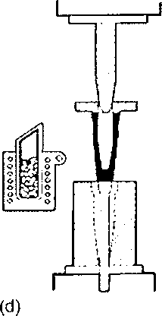

Figure : Schematic illustrating squeeze casting process operations, (a) Melt charge, preheat, and lubricate tooling, (b) Transfer melts into die cavity, (c) Close tooling, solidify melt under pressure, (d) Eject casting, clean dies, charge melt stock.

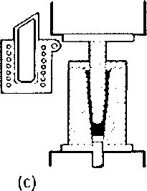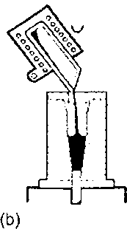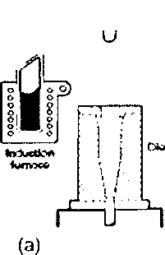

**Tundish**

**Strand**

Submerged Entry Nozzle

Support roll

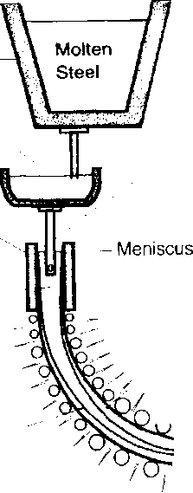

**Solid Billet**

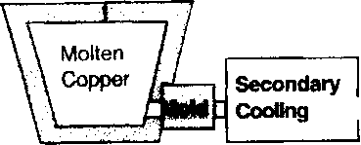

**Ladle**

**Holding**

**Furnace**

Molten

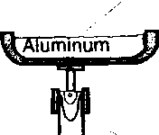

**Mold**

. Liquid Pool

Spray

Cooling

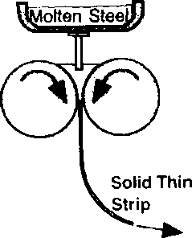

Torch Cutoff Point /

I

Solidifying

Metallurgical

**Solid Steel**

Ul \Length .

**do** go o **Slab**

Twin

Rolls

] CZ1

Strip Casting

Vertical

0 0 0 0"TT Curved

Horizontal

B.G. Thomas, 2000.

The steel is still glowing hot but has solidified oil the way through when it is cut into slabs by means of oxygen lonces. The temperature is 1.000*C. Every slab is marked before it is placed on the cooling bed.

**Figure 1. Various continuous casting processes**

The molten steel can be tapped from the bottom of the ladle into an intermed­iate container known as the tundish. The temperature of the melt is now below 1.60CTC,

Cooling continues by quenching with water along the whole of the strand.

The open mould consists of four water- cooled plates between which the hot steel slides. A solidified shell is formed during casting. The casting temperature is around 1,S40°C.

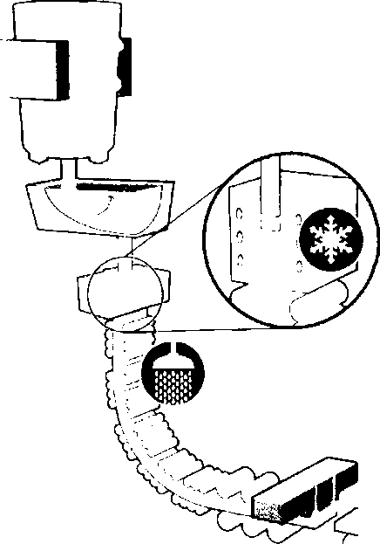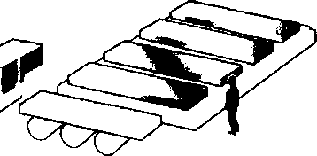

Thomas, B.G., “Continuous Casting,” The Encyclopedia of Materials: Science and 1

Technology, K.H. J. Buschow, R. Cahn, M. Flemings, B. Ilschner, E. J. Kramer, S. Mahajan,

(D. Apelian, subject ed.) Elsevier Science Ltd., Oxford, UK, Vol. 2, 2001, pp. 1595-1599; and online at <http://www.elsevier.eom/mrwelus/l> 5/show/Main.htt.

Continuous Casting

B.G. Thomas Mechanical & Industrial Engineering University of Illinois at Urbana-Champaign bgthomas(o^uiuc.cdu

Continuous casting transforms molten metal into solid on a continuous basis and includes a variety of important commercial processes. These processes are the most efficient way to solidify large volumes of metal into simple shapes for subsequent processing. Most basic metals are mass-produced using a continuous casting process, including over 500 million tons of steel, 20 million tons of aluminum, and 1 million tons of copper, nickel, and other metals in the world each year.

Continuous casting is distinguished from other solidification processes by its steady state nature, relative to an outside observer in a laboratory frame of reference. The molten metal solidifies against the mold walls while it is simultaneously withdrawn from the bottom of the mold at a rate which maintains the solid I liquid interface at a constant position with time. The process works best when all of its aspects operate in this steady-state manner.

Relative to other casting processes, continuous casting generally has a higher capital cost, but lower operating cost. It is the most cost- and energy- efficient method to mass-produce semi­finished metal products with consistent quality in a variety of sizes and shapes. Cross-sections can be rectangular, for subsequent rolling into plate or sheet, square or circular for long products, and even “dog-bone” shapes, for rolling into I or H beams.

Many different types of continuous casting processes exist. Figure 1 pictures a few of the most important ones. Vertical machines are used to cast aluminum and a few other metals for special applications. Curved machines are used for the majority of steel casting and require bending and / or unbending of the solidifying strand. Horizontal casting features a shorter building and is used occasionally for both nonferrous alloys and steel. Finally, thin strip casting is being pioneered for steel and other metals in low-production markets in order to minimize the amount of rolling required.

1. Steel Continuous Casting

Continuous casting is a relatively new process in historical terms. Although the continuous strip casting process was conceived by Bessemer in 1858, the continuous casting of steel did not gain widespread use until the 1960s. Earlier attempts suffered from technical difficulties such as ‘"breakouts1’, where the solidifying steel shell sticks to the mold, tears, and allows molten steel to pour out over the bottom of the machine. This problem was overcome by Junghans in 1934 by vertically oscillating the mold, utilizing the concept of “negative strip” where the mold travels downward faster than the steel shell during some portion of the oscillation cycle to dislodge any sticking.11! Many other developments and innovations have transformed the continuous casting process into the sophisticated process currently used to produce over 90% of steel in the world today, including plain carbon, alloy and stainless steel grades.11[1]

Contents

Introduction

How casting is done continuously Tundish

Mold secondary cooling

Heat transfer in continuous casting

Product and casting defect

Keywords: continuous casting, tundish metallurgy, secondary cooling, defects in cast product Introduction

In the continuous casting, molten steel is poured from the tundish in the water cooled mold and partially solidified bloom/billet or slab (hereafter called strand) is withdrawn from the bottom of the mold into water spray so that solidified bloom/billet or slab is produced constantly and continuously. Continuous casting is widely adopted by steelmakers. The advantages of continuous casting over ingot casting are

Die Casting (Pressure Die Casting)

Die casting refers to the forcing, by pressure of molten metal into a metal die or mould. The term 'die' used in this process implies a metallic mould which is filled under pressure. In this process, metal castings with great surface detail, dimensional accuracy, and extremely thin walls can be produced. Wall thickness within castings can be manufactured as small as 0.5mm.

Die Casting Dies (Die Construction)

* Dies, or die casting tooling, are made of alloy tool steels in at least two sections, the fixed die half, or cover half, and the ejector die half, to permit removal of castings. Modern dies also may have moveable slides, cores or other sections to produce holes, threads and other desired shapes in the casting.
* Die cavities are made with great accuracy usually by machining process. Dies for both the hot and cold-chamber machines are similar in construction because there is little difference in the method of holding and operating them.
* Sprue holes in the fixed die half allow molten metal to enter the die and fill the cavity.
* The ejector half usually contains the runners (passageways) and gates (inlets) that route molten metal to the cavity.
* Vents and small overflow wells are provided on one side of a die;

o to facilitate the escape of air and

o to catch surplus metal that has passed through the die cavity.

* In spite of this provision, there is a certain amount of flash metal which is trimmed off in the finishing operation e.g., grinding or blanking (press shearing).
* Dies also include locking pins to secure the two halves, ejector pins to help remove the cast part, and openings for coolant and lubricant.
* The surface where the ejector and fixed halves of the die meet and lock is referred to as the "die parting line."
* The total projected surface area of the part being cast, measured at the die parting line, and the pressure required of the machine to inject metal into the die cavity governs the clamping force of the machine.

Characteristics of Die Metal

* Die casting dies are usually made of an alloy steel (tool steel, mold steel, or maraging steel) having the following characteristics:
* It should be dimensionally stable.
* It should have high resistance to heat.
* It should not get soldered to the cast alloy.
* It should resist erosion.
* It should have high wear resistance and toughness.
* Tungsten and molybdenum (good refractory qualities) used to die cast steel and cast iron ♦> for tin and lead alloy casting, dies are made of carbon steels without heat treatment,
* for zinc, aluminium and magnesium, dies are of heat treated low-alloy steel,

•> for copper-base castings, heat treated special alloy steel dies are used.

Types of Dies

There are four types of dies:

1. Single cavity to produce one component
2. Multiple cavity to produce a number of identical parts (several castings with each cycle)
3. Unit die to produce different parts at one time
4. Combination die to produce several different parts for an assembly.

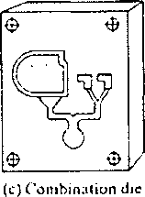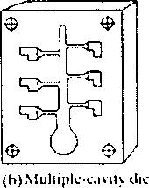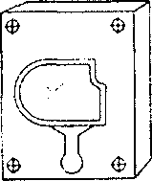

(a) Single-cavity die

$



y

$

to

(d}Umt die

w

During the design of die casting dies, the following points should be kept in view in addition to the considerations given for sand casting design:

* Die casting should be so designed that the cost of flash removal is minimum.
* Artificial means of venting are essential to have sound castings free from porosity.
* The runners and risers should be so located that they facilitate the removal of the casting.
* Proper type and simplest possible shape of cores should be provided.
* Keep sections as uniform as possible. Where sections must be varied, make transitions gradual to avoid stress concentration.
* Die casting design must provide for location of ejector pins. The location of ejector pins is largely determined by the location and magnitude of metal shrinkage on die parts as metal cools in the die.
* Design die castings to minimize machining. Where machining is specified, allow sufficient metal for required cuts.
* In manufacturing industry it is of concern to keep the mold cool. Die may have special passages built into them that water is cycled through in order to keep down thermal extremes.

THE DIE CASTING CYCLE

* In the casting cycle, first the die is closed and locked. The molten metal, which is maintained by a furnace at a specified temperature, then enters the injection cylinder.
* During the injection stage of the die casting process, pressure is applied to the molten metal, which is then driven quickly through the feed system of the die while air escapes from the die through vents.
* The volume of metal must be large enough to overflow the die cavities and fill overflow wells.
* Once the cavities are filled, pressure on the metal is increased and held for a specified dwell time during which solidification takes place.
* The dies are then separated, and the part extracted, often by means of automatic machine operation.
* The open dies are then cleaned and lubricated as needed, and the casting cycle is repeated.
* The lubricant will assist in cooling down the dies as well as preventing the metal casting from sticking to the mold.
* Following extraction from the die, parts are often quenched and then trimmed to remove the runners, overflow wells and any parting-line flash that is produced.
* Subsequently, secondary machining and surface finishing operations may be performed.

Types of Die Casting Machines Hot Chamber Machine

It consists of a suitable furnace for melting and holding the metal. When the plunger is raised, it uncovers an opening or port in the chamber wall, through which the metal enters, filling the chamber.

In operation, the plunger is forced downwards pneumatically or hydraulically, closing the- opening and then forcing the confined metal up through a suitable channel and nozzle into the die. After a predetermined time, the plunger is again raised, allowing the molten metal in the channel and nozzle to drop back. The die is opened and the solidified die casting is ejected.

Metal injection speeds and pressures are controllable to suit different metals and castings. To attain uniformity and maximum speed of operation, a predetermined and automatically controlled cycle for various operations should be used. Operator is however required to remove the casting from the die, inspect and sometimes lubricate it.

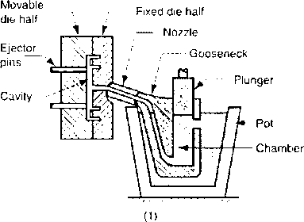

Hot-chamber machine

Limitations

Hot chamber machines are used with low-melting alloys because of:

* Machine difficulties encountered at high temperatures.
* The increased corrosion of the machine parts.
* Since many metals have an affinity for iron, only those casting alloys, which do not attack the immersed metal parts are used. Alloys of zinc, tin and lead are particularly recommended for these machines.
* Die casting of brass, aluminium and magnesium requires higher pressures and melting temperatures. Hence, a change in the melting procedure is necessary. These metals are not melted in a self-contained pot, since the life of the pot would be very short.

Cold Chamber Machine

o The molten metal is ladled from the melting pot into a pouring slot in the main pressure chamber

o A close fitting plunger is rammed forward by hand or pneumatic action. This confines the metal against the die opening and actually squirts it into the die at pressures of 400 to 1500 kg/cm2 and higher.

o Because most die castings are of thin section (usually 3 mm or less), solidification is extremely rapid. After the casting is solid, the die halves are opened and cores are withdrawn.

o High melting point alloys of aluminum, brass, copper, and aluminum-zinc are often cast in manufacturing industry using cold chamber die casting.

o The cold die casting process requires the application of more pressure than hot-chamber machines.

o Aside from the ladling procedure, the operation of the machine is the same for hot-chamber machines.

Movable

* Die casting is an efficient, economical process offering a broader range of shapes and components than any other manufacturing technique.
* Die casting provides complex shapes within closer tolerances than many other mass production processes. Little or no machining is required and thousands of identical castings can be produced
* Die casting produces parts that are durable and dimensionaily stable.
* Thin wail castings are stronger and lighter than those possible with other casting methods.
* Die castings do not consist of separate parts welded or fastened together, the strength is that of the alloy rather than the joining process.
* Die cast parts can be produced with smooth or textured surfaces, and they are easily plated or finished with a minimum of surface preparation.
* Thin sections can be cast with good surface finish. Details can be reproduced successfully with a high degree of precision

Disadvantages of Die Casting

* High cost of the equipment and dies used requires sufficiently large quantities to compete economically with other processes. For die casting, minimum economic quantity is considered to be about 20,000.
* There is a rapid decrease in the life of the dies as the metal temperature increases.
* In some cases, there is an undesirable chilling effect on the metal.
* Metals having a high coefficient of contraction must be removed from the mould as soon as possible because of the inability of the mould to contract with the casting.
* There are certain limitations in the shape of die castings and the process is not adapted to the production of large castings. So far, the maximum size cast is 100 kg in zinc and 30 kg in aluminium.
* Die castings usually contain some porosity due to the entrapping of air.
* Die casting has, to a large extent, been limited to low-melting non-ferrous alloys. With a gradual improvement of heat-resisting metals for dies, this process can now be used for numerous alloys.

Die-Casting Alloys

The four major types of alloys that are die-cast are zinc, aluminum, magnesium, and copper-based alloys. Lead and tin are now very rarely die-cast because of their poor mechanical properties.

* Zinc base alloys

The easiest alloy to cast. Over 75% of die castings produced are the zinc base type. Zinc is economical for small parts, has a low melting point and promotes long die life.

The purest grades of commercial zinc, 99.90%, known as Special High grade, should be used, since impurities like lead, cadmium, tin cause serious casting and aging defects.

* Aluminium base alloys

Many die castings are made of aluminium. Compared to zinc alloys, however, they are slightly lower in physical properties and more difficult to die cast. Aluminum alloys have the disadvantage of requiring the use of cold-chamber machines, which usually have longer cycle times than hot-chamber machines owing to the need for a separate ladling operation. Although more expensive to operate than the air injection type, it has advantage of producing sounder castings

* Copper-base Alloys

Die castings of brass and bronze present more problems in pressure casting because of their high casting temperatures . Heat-resisting alloy steel dies are used to reduce their rapid deterioration. Cost of brass die castings is, therefore, comparatively higher.

Difficulties of rapid oxidation of steel dies due to high temperatures involved have been largely overcome.

* by improvement in die metals and
* by casting at as low a temperature as possible.

Some machine is designed to use metal in a semi-liquid or plastic state to permit operation at lower temperatures than those used for liquid metal. To protect the dies further from overheating, water is circulated through plates adjacent to the dies. Metal is maintained under close temperature control and is ladled by hand to the compression chamber.

* Magnesium-base Alloys

The principal die casting alloy of magnesium having good casting characteristics. The easiest alloy to machine, magnesium has an excellent strength-to-weight ratio and is the lightest alloy commonly die cast.

|  |  |  |  |  |
| --- | --- | --- | --- | --- |
| Characteristics of Die Casting Alloys | | | | |
|  | Aluminum | Brass | Magnesium | Zinc |
| Dimensional stability | Good | Excellent | Excellent | Good |
| Corrosion resistance | Good | Excellent | Fair | Fair |
| Casting ease | Good | Fair | Good | Excellent |
| Part complexity | Good | Fair | Good | Excellent |
| Dimensional accuracy | Good | Fair | Excellent | Excellent |
| Die cost | Medium | High | Medium | Low |
| Machining cost | Low | Medium | Low | Low |
| Finishing cost | Medium | Low | High | Low |

|  |  |  |  |  |
| --- | --- | --- | --- | --- |
| Processing and Production | | | | |
| Machine Types: | Aluminum | Brass | Magnesium | Zinc |
| Hot chamber (Plunger) | No | No | Yes | Yes |
| Cold chamber | Yes | Yes | Yes | Yes |
| Production range, shots/hr | 40-200 | 40-200 | 75-400 | 200-550 |
| Average tool life, no, of shots x 1000 | 125 | 20 | 200 | 500 |

**Manufacturing processes**

The word manufacture is derived from two Latin words manus (hand) and factus (make); the combination means "made by hand".

Most modern manufacturing operations are accomplished by mechanized and automated equipment that is supervised by human workers.

Manufacturing is the process of converting raw materials into products by various processes, machinery, and operations, following a well-organized plan for each step.

Manufacturing definition- Technologically

Application of physical and chemical processes to alter the geometry, properties, and/or appearance of a given starting material to make parts or products

B Manufacturing also includes the joining of multiple parts to make assembled products

* Accomplished by a combination of machinery, tools, power, and manual labor.

° Almost always carried out as a sequence of operations

Manufacturing definition - Economically

Transformation of materials into items of greater value by means of one or more processing and/or assembly operations.

Manufacturing adds value to the material by changing its shape or properties, or by combining it with other materials.

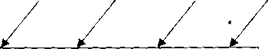

Materia

Tools & Maehin

Energ Labo

Manufacturing



Starting

material

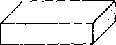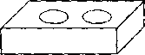

►



and/or

Figure 1.1- Manufacturing as a technical process

* Polymers

Polymers are often composed of organic compounds and consist of long hydro­carbon chains.

Three categories:

* Thermoplastic polymers - can be subjected to multiple heating and cooling cycles without altering molecular structure. Polymers that become soft and formable upon heating. (PE, PVC Pipes,... etc.).
* Thermosetting polymers - molecules chemically transform (cure) into a rigid structure - cannot be reheated.(pheolics, epoxies,... etc.).
* Elastomers - shows significant elastic behavior. (rubber, silicone,...etc.).
* Composites

Material consisting of two or more phases that are processed separately and then bonded together to achieve properties superior to its constituents . They may exhibit superior properties.

* Phase - homogeneous mass of material.
* Properties depend on components, physical shapes of components, and the way they are combined to form the final material
* Examples; Fiber-reinforced plastic, Ceramic in metal matrix.

Classification Of Manufacturing Processes

Manufacturing may be classified according to various types of processes:

A- Processes used to change the shape of material, such as Extraction from ore, Casting, Powder metallurgy forming, Plastics molding .

B- Processes used for machining parts to a fixed dimension

1. Traditional machining (chip removal), such as Turning, Planning, Drilling, Milling, ...etc.
2. Non traditional machining, such as Ultrasonic, Electrical discharge, Optical laser, electrochemical, ..etc.

C- Processes for obtaining surface finish, such as polishing, electroplating, metal spraying, coatings, ...etc.

D- Processes used for joining parts or materials, such as Welding, Soldering, Brazing, Screw fastening, Adhesive joining....etc.

E- Processes used to change physical properties, such as heat treatment, shot peening,..etc.

Casting is an operation of shaping metal by pouring it in the liquid state (molten metal) into a mold cavity followed by solidification. Also, casting is the process of solidifying a liquid into a solid in a desired shape.

A casting is also a metal detail, produced as a result of pouring a metal into a mold. A Foundry is a casting factory which equipped for making molds, melting and handling molten metal, performing the casting process, and cleaning the casting.

The metal casting process is the simplest, most direct route to a near net shape product, and often the least expensive. Casting processes can produce components with complex shapes and desired properties. Metal castings quality is determined by the casting properties of the metal.

* Advantages
* Complex geometries - external and internal
* Can be net-shaped or near net-shaped
* Can produce very large parts -Any metals
* Can be mass-produced
* Size variety - big and small
* Disadvantages
* Limitation in mechanical properties, porosity,
* Dimensional accuracy, surface finish
* Safety Hazard
* Environmental problems

Two Main Categories of Metal Casting Processes 1.Expendable mold processes -

* A mold after process must be destroyed in order to remove casting.
* A new mold is required for each new casting.
* Production rates often limited by time to make mold rather than casting itself.
* more complex shapes possible.
* Mold materials: sand, plaster and similar materials + binders.

Examples; Sand, lost wax, lost foam, shell, slurry, investment

1. Permanent mold processes -

* Mold is made of metal and can be used to make many castings.
* Part shapes are limited
* Permanent mold processes are more economic in high production operation;
* Mold: made of metal and, less commonly, a ceramic refractory material Examples; die casting, hot chamber, cold chamber

' 1 1

(if needed) i i ; making

Preparation of Sand

Sand

making

Heat Treatment (if needed)

Removal of I I 1 Cleaning &

|—

sand mold I 1 Finishing

Mold

Raw

metal

Pouring into mold

Melting Of Metal

Solidification and cooling

Finished

casting

Inspection

Figure 1.3 - Steps in the production sequence in sand casting The steps include not Only the casting operation but also pattern-making and mold-making

Sand casting mold

The typical mold for a sand casting is shown in the picture:

Vent

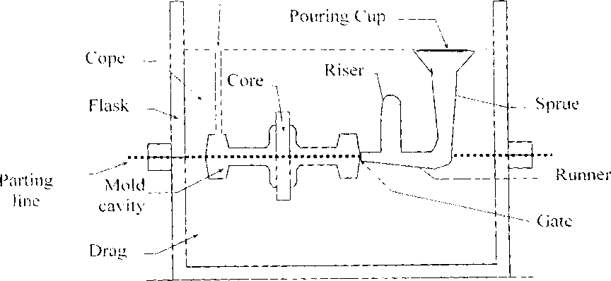

Figure 1.4 - Typical mold for a sand casting

**Types of molds Green-Sand Molds:**

A green sand mold is very typical in casting manufacture, it is simple and easy to make, a mixture of sand, clay and water. The term green refers to the fact that the mold will contain moisture during the pouring of the casting.

* Possess sufficient strength for most casting applications
* Good collapsibility
* Good permeability
* Good reusability
* Least expensive of the molds used in sand casting manufacturing processes
* Moisture in sand can cause defects in some castings, -dependent upon the type of metal used in the sand casting and the geometry of the part to be cast.

**Dry-Sand Molds:**

Dry-Sand molds are baked in an oven, (at 300F - 650F for 8-48 hours), prior to the casting operation, in order to dry the mold. This drying strengthens the mold, and hardens its internal surfaces. Dry-Sand molds are manufactured using organic binders rather than clay.

* Better dimensional accuracy and surface finish of cast part.
* More expensive manufacturing process.
* Manufacturing production rate of castings are reduced due to drying time.
* Distortion of the mold is greater
* Generally limited to the manufacture of medium and large castings. Skin-Dried Molds:

When sand casting a part by the skin-dried mold process a green-sand mold is employed, and its mold cavity surface is dried to a depth of 1.25-2.5 mm (0.5 -1 inch). Drying is a part of the manufacturing process and is accomplished by use of torches, heating lamps or some other means, such as drying it in air.

* Mold surfaces are dried
* Used for large castings
* Have higher strength than green-sand molds
* Better dimensional accuracy and surface finish
* Drawbacks:
* Distortion to the mold is greater
* Castings susceptible to hot tearing
* Slower production rate

Silica sand (Si02) with additives (or silica mixed with other minerals) is used for sand casting.

**Properties of a Sand Casting Mixture:**

**Moisture Content:**

Moisture content affects the other properties of the mixture such as strength and permeability. Too much moisture can cause steam bubbles to be entrapped in the metal casting.

**Grain Size:**

This property represents the size of the individual particles of sand.

* Small grain size yields better surface finish on the cast part, can be closely packed, have lower mold permeability and enhances mold strength
* Large grain size is more permeable, to allow escape of gases during pouring Shape of Grains:

This property evaluates the shape of the individual grains of sand based on how round they are. Less round grains are said to be more irregular.

Irregular grain shapes tend to strengthen molds due to interlocking, compared to round grains which provide a better surface finish).

Disadvantage of interlocking: tends to reduce permeability.

**Strength:**

The strength is, the ability of the sand casting mixture to hold its geometric shape under the conditions of mechanical stress imposed during the casting process (ability to retain mold shape during packing and pouring).

**Permeability:**

The ability of the sand mold to permit the escape of air, gases, and steam during the casting process ( gases liberated from the mold and solidifying metal). Collapsibility:

The ability of the sand mixture to collapse under force (Or ability of the sand to be shake out).

**Flowability:**

The ability of the sand mixture to flow over and fill the casting pattern during the impression making phase of the manufacturing process, more flowability is useful for a more detailed casting.

**Refractory Strength:**

During the pouring of the molten metal in sand casting manufacture, the sand mixture in the mold must not melt, burn, crack, or sinter. The refractory strength is the ability of the mold sand mixture to withstand levels of extreme temperature. Reusability:

The ability of the sand casting mold sand mixture to be reused to produce other castings in subsequent manufacturing operations

**Patterns materials:**

* Wood - common material because it is easy to work, but it warps
* Metal - more expensive to make, but lasts much longer
* Plastic - compromise between wood and Metal
* A parting (release) agent is applied on the pattern surface in order to provide easy removal of the pattern from the mold.
* Patterns may be made as one-piece or multiple-piece (split, match plate).
* Patterns are commonly made larger than the casting because of the shrinkage effect. Also, due to machining or finishing allowance. Shrinkage allowances are usually 1-2%.
* The pattern surfaces are never made perpendicular to the mold parting surface. The taper of the pattern surface, which provides narrowing the mold cavity towards the mold parting surface is called draft. Draft allows easy removal of the pattern and the casting from the sand mold.

The draft angle is commonly 1-3%.

* Fillets: All sharp corners must be rounded to facilitate molding and filling.

Shrinkage allowance is the correction factor built into the pattern to compensate for the contraction of the metal casting as it solidifies and cools to room temperature. The pattern is intentionally made larger than the final desired casting dimensions to allow for solidification and cooling contraction of the casting.

Because different shrinkage allowances must be used for the individual types of metals cast, it is not possible to use the same pattern equipment for different cast metals without expecting dimensional changes. For internal cavities the allowances should be negative.

The machine finish allowance provides for sufficient excess metal on all cast surfaces that require finish machining. The required machine finish allowance depends on many factors:

o the metal cast, the size and shape of the casting, o casting surface roughness and surface defects that can be expected,

o the distortion and dimensional tolerances of the casting that are expected.

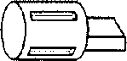

, Pattern

Pla’e

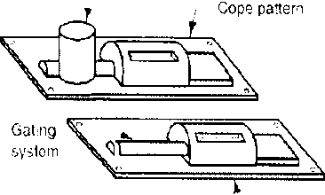

Drag

pattern

*f*

/ \ q 1

NL__-~J==a



E3?

(a)

(b)

(c)

(d)

Figure 1.5 - Types of patterns used in sand casting:

1. solid pattern
2. split pattern
3. match-plate pattern
4. cope and drag pattern

* Draft ani.'li

PfiMcrn

Da mi me

riiisk

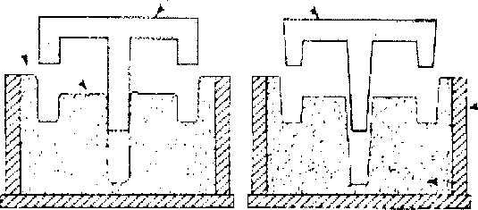

Sand mold

(jood

Poor

Figure 1.6 - Taper consideration in sand casting

Non-Conventional Welding Processes **Electron Beam Welding**

In this process heat is generated by a narrow beam of high-velocity (energy) electrons The beam is directed to hit at the desired spot of the workpiece.

The kinetic energy of the electrons is converted into heat as they strike the workpiece. The metal is joined by melting the edges of the workpiece or by penetrating the material. The process is carried out in a vacuum chamber.

Typical application include welding of aircraft, missile, and electroni components and gears and shafts in the automotive industry.

High-voltage cable (30 kV, DC)

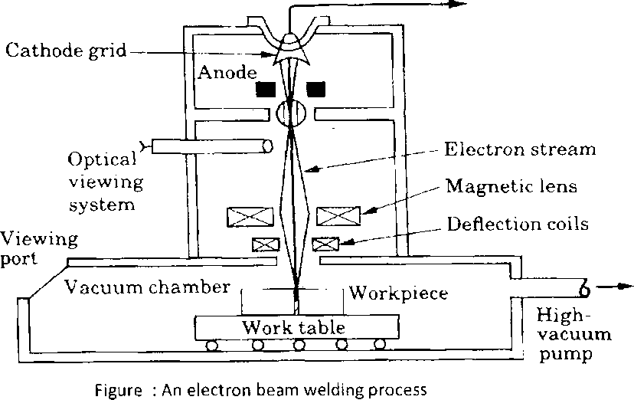

Advantages

* It produces very high-quality welds.
* There is no requirement of shielding gas, flux and without the application of pressure. .
* distortion and shrinkage in the weld area is minimum.
* Narrow weld and narrow heat affected zone.
* Almost all metals can be welded.
* Thinner as well as thicker workpieces can be joined.
* Because of sharp focus of laser beam, the process finds extensive applications in electronic industries to connect wire leads to small electronic components.
* Laser Welding is used in electronics, communication and aerospace industry, for manufacture of medical and scientific instruments.

**Advantages**

* It gives deep penetration without affecting the surrounding metal (narrow weld and very small heat affected zone).
* The quality- of the weld is better because thermal distortion is minimum.
* The laser beams do not generate X-rays as in case of electron beam welding.
* The process can easily be automated.
* Vacuum is not required;
* A wide variety of similar and dissimilar metals can be joined
* Thin workpieces are most effectively welded Limitations
* Better design for the weld joint and edge preparation are absolutely essential to produce the narrow gap. .
* The cost of equipment is very high.
* The process is limited to very thinner materials.
* Laser beams are hazardous causing injury to eyes and skin.

**Ultrasonic Welding (USW)**

In this process a bond is produced by ultrasonic vibratory energy in the weld region. The workpieces (metals) are clamped together under pressure , and high frequency vibrations are introduced into these metals through a welding tip or sonotrode. The vibration break up the surface films(due to friction between the parts) and causes the solid metals to bond tightly together.

* The temperature at the weld is not raised to the melting point and therefore has no nugget similar to resistance welding.
* The normal weld is the lap joint weld.
* Most ductile metals can be welded together.
* Ultrasonic Welding is used mainly for bonding small work pieces in electronics, for manufacturing communication devices, medical tools, watches, in automotive industry.

**Advantages**

* Dissimilar metals may be joined.
* Very low deformation of the work pieces surfaces.
* The process can be automated.
* Moderate operator skill level is enough.

**Disadvantages**

* Only small and thin parts may be welded;
* Work pieces may bond to the anvil.

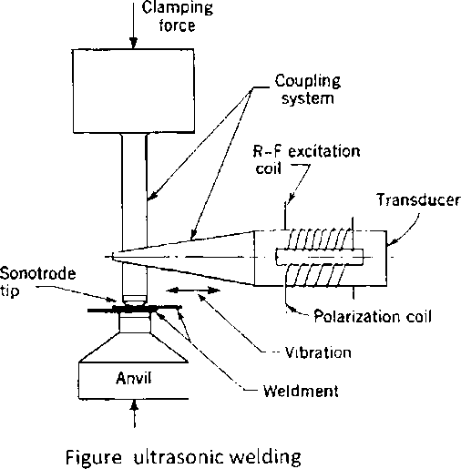

Fluid Flow and Gating Design

There are many factors that must be controlled if a good casting is to be obtained. Also, there are many requirements must be met in order to minimize casting defects.

**General Design Rules for Casting**

* Design the part so that the shape is cast easily.
* Select a casting process and material suitable for the part, size, mechanical properties, etc.
* Locate the parting line of the mold in the part.
* Locate and design the gates to allow uniform feeding of the mold cavity with molten metal.
* Select appropriate runner geometry for the system.
* Locate mold features such as sprue, screens and risers, as appropriate.
* Make sure proper controls and good practices are in place.

Molten metal is introduced into the mold cavity through a gating system, composed of four main parts: a basin, a sprue, a runner, and gates.

**An ideal gating system should fulfill the following functions:**

1. Fill the mould cavity
2. Introduce the metal into the mold cavity with as little turbulence as possible(lmportant characteristics in fluid flow is Turbulence as opposed to Laminar or Smooth Flow)
3. Develop the best temperature gradients in the casting
4. Control the rate of entry of metal into the mold cavity

**The gating system will function properly in the production of good castings if the following aspects are carefully controlled:**

1. Rate of pour into the basin.
2. Size and type of sprue and runners leading to the casting.
3. Type of pouring equipment, such as ladles, runner cups, and basins.
4. The temperature of the metal to be poured.
5. The use of risers when heavy sections are involved.
6. Size and shape of gates.

Whether the flow is turbulent or smooth (nature of flow in the gating system) depend on the velocity of the liquid, the cross section of the flow channel, and the viscosity of the liquid. The relationship is expressed as the Renolds number, Rn:

n velocity of flow x diameter of channel x density of liquid

Rn —

viscosity of the liquid

Rn = vdp/n

Where :

Rn = Renolds number

v - velocity of flow in cm/s d = diameter of the channel in m p = fluid density in gm/cm3 \i - the viscosity of the fluid in poise

An Rn value of up to 2000 represents laminar flow

An Rn Between 2000 and 20000 it is a mixture of laminar and turbulent flow and is generally regarded as harmless in gating systems for casting Rn values in excess of 20000 represent severe turbulence.

As far as possible the turbulent flow must be avoided in the sand mold.

*Excess turbulence causes*

* Inclusion of dross or slag(^^' j' Sjc- j)
* Air aspiration into the mold
* Erosion of the mold walls

*Turbulence can be avoided by (Elimination techniques):*

* Avoid sudden changes in fluid flow
* Avoid sudden changes in cross section
* 'dross' can be reduced by filters ( ceramic, mica)
* Also with proper pouring basin and gating system

**Example:**

Show whether the flow is turbulent or smooth of a fluid, with density equal to 3.0 gm/cm3, viscosity 0.001 N. s/m2, velocity of 1.4 m/s, and diameter of flow channel equal to 0.5 cm ?

**Solution:**

*vdp*

Calculate the Renolds number K„ —

A*

1.4y x 0.5 *cm x 3gm/cm*3 *~ ~~~n~s*

0.001-^r

mz

Rn = 21000 flow is turbulence !

**Example:**

How fast (velocity) would a stream of a fluid, (2.54 cm) in diameter, need to be turbulent?

Density (p) = 1.43 g/cm3 (at 20°C)

Viscosity [r\) = 189 poise (at 20 °C)

*vdp*

Rn -

V X 0.254 X 1430

=

KU 18.9

Turbulent flow transition

Rn~ 2000

Rn = 2000 = 1430 xv x 0.0254 / 18.9 v - 1040 m/s

Molten Metal Flow

In the design of gating systems, one uses two basic fluid-flow equations to take velocity into account. The first, is the law of continuity, states that for an incompressible liquid the rate of flow is constant.

From this law, we can calculate the velocity and the rates of flow of liquid metal, this may be written

*Q* = *AiVi = A2V2* Where

Q. = volumetric flow rate, cm3/s A = cross sectional area of flow channel, cm2 v = velocity of fluid flow, cm/s

* Subscripts 1 and 2 pertain to two different locations in the system.

**Example:**

In the runner system shown in the figure below, the rate of flow of metal (Q) is 300 cm3/ sec, cross section area of runner at point(l) is 10 cm2, and cross section area at point (2) is 5 cm2, Calculate velocity at points (1) and (2) in the runner system?



Ai

l

2

A2

v2

**Solution:**

Continuity law: Q = A1V1 = A2V2

Q 300

Vl = ~A = To"= 30 cmfsec

Q 300 v2 = — = —— = 60 cm/sec

A2 5

When the cross section of the runner is reduced to half its original size, velocity of the metal is doubled.

**Molten Metal Flow**

The basic law of hydraulics, known as Bernoulli's theorem, gives relationships between the factors that influence the fluid behavior of molten metal.

* *Bernoulli's Theorem* Based on
* principle of conservation of energy
* frictional losses in a fluid system

E + **—** -\- f — **constant**

*p*

h = elevation from reference plane (height of liquid), m

P = pressure at the elevation(static pressure), kg/cm2

p = density of fluid, kg/m3

v = velocity of the fluid (metal velocity), m/s

g = gravitational constant (acceleration due to gravity), 9.81 m/s2

f- friction (head losses due to friction), m

Bernoulli's Theorem - the sum of energies (head, pressure, kinetic, and friction) at any two points in a flowing liquid are equal

1 P 2g 1 p 2g }l

Assuming no frictional loss and same pressure

hx + ^ = h2 + ^

1 2 g z 2 g

Assuming point 2 is reference (i.e. at the base of sprue), (h2= 0) and (v1 = 0)

1

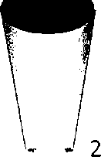

*hi = ~*

1 2 g

Mold filling time estimate

* Time to fill a mold cavity:

***T --***

MF ~ Q

*rj., _ Mold volum*

*1mf ~* 7^

A. cross sectional area v - velocity

Example Design and analysis of a sprue for casting The desired volume flow rate of the molten metal into a mold is 0.01 m3/min. The top of the sprue has a diameter of 20 mm and its length is 200 mm.

What diameter should be specified at the bottom of the sprue in order to prevent aspiration?

What is the resultant velocity and Reynolds number at the bottom of the sprue if the metal being cast is aluminium and has a viscosity of 0.004 N-s/m2 ?

31

*Solution*

Since di = 0.02 m ^

A.=-d2 = — (0.002)2 = 3.14x 10-4 m2 4 4

The metal volume flow rate is Q= 0.01 m3/min = 1.667*10'4 m3/s

1. Top, 2 bottom of sprue Therefore

Q 1.667 x 10 4

v, = — = —r = 0.53 1 m/s

Ax 3.14x10

Assuming no frictional losses, and recognizing that the pressure at the top and bottom of the sprue is atmospheric

Thus,

/1i + £i+j£ + /i= h2+vi+d+ f2

1 P 2g J1 z p 2g yz

p 2(9.81) p 2(9.81)

***V****2* ***=* 1.45 m/s** Q = *A 2 v 2* 1.667xl0'4= A2 X 1.45

A2 - 1.15 X10'4 m2

A2 d2 z 4

1.15 X 10 4 = - d2 d = 12 mm

Aluminum density: p-2100kg I nr''

Re = vDp = {L45X0XM2)(2700) = 11 745 77 0.004

Chvorinov's rule for solidification time for a mold

* Solidification time is proportional to volume of casting and its surface area
* Solidification takes time
* Total solidification time TST = time required for casting to solidify after pouring
* TST depends on size and shape of casting by relationship known as Chvorinov's Rule



Where:

TST = total solidification time;

V = volume of the casting;

A - surface area of casting; n = exponent with typical value = 2; and Cm is mold constant.

* Mold constant Cm depends on:
* Mold material
* Thermal properties of casting metal
* Pouring temperature relative to melting point
* Value of Cm for a given casting operation can be based on experimental data from previous operations carried out using same mold material, metal, and pouring temperature, even though the shape of the part may be quite different
* A casting with a higher volume-to-surface area ratio cools and solidifies more slowly than one with a lower ratio
* To feed molten metal to main cavity, TST for riser must greater than TST for main casting
* Since mold constants of riser and casting will be equal, design the riser to have a larger volume-to-area ratio so that the main casting solidifies first
* This minimizes the effects of shrinkage *Example Solidification times for various solid shapes*

Three pieces being cast have the same volume but different shapes. One is a sphere, one a cube, and the other a cylinder with a height equal to its diameter. Which piece will solidify the fastest and which one the slowest? Use n = 2.

*Solution*

Solidification lime cc - -r

(Surface area)"

* Assume volume to be unity Respective surface areas c

— I = 4.84 4tt

Sphere \A-4n

Cube: A — 6a2 = 6 Cylinder: A = 2mj2 + 2m'h = 5.54

Respective solidification times t are:

* Tsphere = 0.043 C
* Tcube = 0.028 C
* Tcylinder = 0.033 C C is a constant

Mechanical molding equipment

Mechanization of molding operation is accomplished by using molding machines which are designed to perform operations of compacting the mold sand and removing the pattern plate.

The common machines are:

* Jolt machine
* Squeezer machine
* Jolt - squeeze machine
* Jolt - squeeze rollover machine
* Diaphragm molding machines
* Jolt rollover pattern-draw machine
* Sand slinger

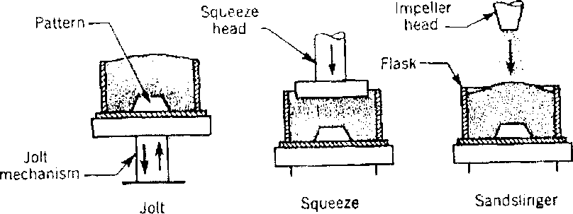

Figure 1.8- Machine molding principles

Figure 1.9 Jolt-squeeze molding machine

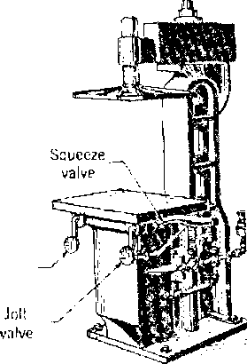

Sand

hopper

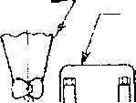

j— Diaphragm

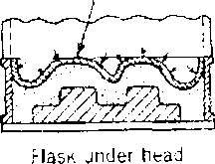

Vibrator A valve

|  |  |  |
| --- | --- | --- |
| -o |  | d01=3l |
| J | Q | ir |

Diaphragm pressure head

Flask

figure 1.10 Contour-diaphragm molding

**Incomplete Casting:**

Sections of the casting did not form. In a manufacturing process causes for an incomplete casting could be;

* insufficient amount of material poured,
* loss of metal from mold,
* insufficient fluidity in molten material,
* cross section within casting's mold cavity is too small,
* pouring was done too slowly,
* pouring temperature was too low.

Misrun, A casting that has solidified before completely filling mold cavity

**Incorrect Dimensions or Shape:**

The casting is geometrically incorrect, this could due to;

* Unpredicted contractions in the casting during solidification.
* A warped casting.
* Shrinkage of the casting may have been miscalculated.
* There may have been problems with the manufacture of the pattern.

Mold Shift, defect occurs when cope and drag or molding boxes have not been properly aligned.

**Inclusions:**

Particles of slag, refractory materials sand or deoxidation products are trapped in the casting during pouring solidification. The provision of choke in the gating system and the pouring basin at the top of the mold can prevent this defect Penetration

When fluidity of liquid metal is high, it may penetrate into sand mold or sand core, causing casting surface to consist of a mixture of sand grains and metal. The coarser the sand grains more the metal penetration.

**Cleaning and Finishing**

A range of finishing processes is usually undertaken, these include:

* cleaning to remove residual sand, oxides and surface scale, often by shot or tumble blasting;
* Removal of excess metal or surface blemishes, by grinding, sawing or cutting;
* Rectification of defects by welding;
* machining;
* Heat treatment, (if needed);
* Priming, painting or application of a rust preventative coating.

**Cleaning process**

* Tumbling barrels

Sand blasting and shot blasting

* Grinding
* Chemical treatment

Inspection Methods

* Destructive inspection, various specimens are removed from various sections to test for strength, durability, porosity, and any other defects. \c ,x\sv< ^

su ^ v'o s , ^\stYvv-’^ c [2] < Vuvu'^y' A

* Non Destructive inspection, all methods which make possible the testing or inspection of a material without impairing its future usefulness.
* Visual inspection to detect obvious defects such as mis runs, cold shuts, and severe surface flaws.
* most widely used
* experienced inspector knows where are defects
* Dimensional inspection (measurements) to insure that tolerances have been met.

Furnaces for Casting Processes

Melting is important parameter for obtaining a quality castings. The choice of furnace, used for melting the metal in foundries, depends on the type of metal to be melted.

Some of the furnaces used in metal casting are as following:

* Cupolas
* Electric-arc furnaces
* Induction furnaces
* Crucible furnaces Cupolas

Vertical cylindrical furnace equipped with tapping spout near base

* Used to melt iron and ferrous alloys in foundry operations, and although other furnaces are also used, largest tonnage of cast iron is melted in cupolas
* The "charge," consisting of iron, coke, flux, and possible alloying elements, is loaded through a charging door located less than halfway up height of cupola
* They operate continuously, have high melting rates, and produce large amounts of molten metal.

A schematic diagram of a cupola is shown in Figure 1. . This diagram of a cupola illustrates the furnace's cylindrical shaft lined with refractory and the alternating layers of coke and metal scrap. The molten metal flows out of a spout at the bottom of the cupola. .

**Electric-Arc Furnaces**

Charge is melted by heat generated from an electric arc.

* High power consumption, but electric-arc furnaces can be designed for high melting capacity.
* Used primarily for melting steel.
* high rate of melting, much less pollution,
* ability to hold the molten metal for any length of time for alloying purposes.

**induction furnaces**

Uses alternating current passing through a coil to develop magnetic field in metal

* Induced current causes rapid heating and melting
* Electromagnetic force field also causes mixing action in liquid metal
* Since metal does not contact heating elements, the environment can be closely controlled, which results in molten metals of high quality and purity
* Melting steel, cast iron, and aluminum alloys are common applications in foundry work

•— Cover

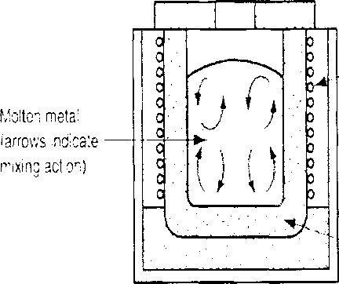

-- Copper induction coils

Figure 1.14- Induction Furnace

Refractor/ material

**Crucible Furnaces**

Crucible furnaces, heated with commercial gases, fuel oil, coke, electricity. Metal is melted without direct contact with burning fuel mixture.

* Sometimes called *indirect fuel-fired furnaces*
* Container (crucible) is made of refractory material or high- temperature steel alloy
* Used for nonferrous metals such as bronze, brass, and alloys of zinc and aluminum
* Small capacity typically used for small melting applications
* Suitable for the batch type foundries

Deformation Processes

* Shape change by plastic deformation
* Forces are applied via specialized equipment, tools and dies
* Workpiece is a cast ingot or previously cast and worked material
* Deformation refines microstructure

**Deformation processes are performed**

* Hot >recrystallization temp. >0.6 Tmelt
* Cold room temp <0.3 Tmelt
* Warm 0.3 - 0.6 Tmelt

Metal Forming

Forming processes are used to produce the desired shape and size through the plastic deformation of the material.

Forming process can be classified into two groups: o Hot working process o Cold working process

**Hot Working vs. Cold Working**

* Hot Working:

Deformation at temperatures above recrystallization temperature

* Less powerful equipment
* Less residual stress
* Ductility is improved
* Shorter tool life
* Scale formation
* Lack dimensional accuracy

Universal roll lor H[3]beams

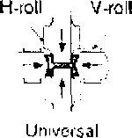

mill

V-roll

itr

° 0 T n ■■■'

**t**

8oam blank

Breakdown

mill

Edging mill '

Universal

mill

H-roll

**f%<§l**

Figure 5: Stages in shape rolling of an H-section. Several o^her structural sections, such as channels and rails, also are rolled by this process.

Ring rolling

•

;

Figure 6 : Schematic illustration of a ring-rolling operation. . ’ .

Reducing the ring thickness results in an increase in its

diameter.

v' Vi) V

Piercing

To produce seamless tubing, cylindrical billets of steel are passed between two conical-shaped rolls operating in the same direction. Between theses rolls is a fixed point or mandrel, which assists in the piercing and controls the size of the hole as the billet is forced over it. The process shown in figure...

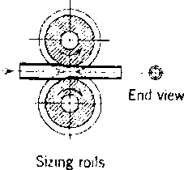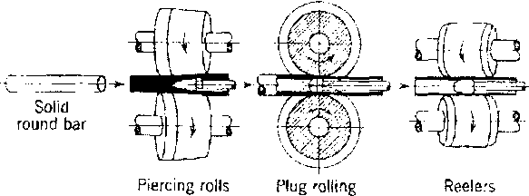

mil!

Figure 7: Principal steps in the manufacture of seamless tubing.

* **Press forging**

Press forging involves a slow squeezing action produced by mechanically or hydraulically operated presses as compared to rapid impact blows of a hammer in drop forging. Most press forging are symmetrical in shape, with surfaces are quit smooth. Forging presses are often used for sizing operations on parts made by other processes.

* Upset forging

In upset forging, only a portion of the work material is deformed in a die, while the remaining part remains unaffected. The starting stock is usually a wire, rod or bar. The process is used to form heads on fasteners such as bolts, screws and rivets. The process shown in figure.

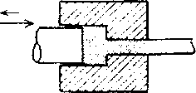

|  |  |
| --- | --- |
|  |  |
| hv.-.: |  |
| 1 . | A |
| V7777,  rr/'T? ?/////,  m-y-m |  |

□

|  |  |  |
| --- | --- | --- |
|  | V'//’,' ' |  |
| b | ^ |
| • v&iA | |
|  |  |
|  |  |

Figure 10 : upset forging

* **Roll forging**

In roll forging, the cross-section of round or flat bar stock is reduced or shaped at the cost of its length. A pair of cylindrical or semicylindrical rolls, each containing one or more shaped grooves according to the shaping required is used. Roll forging is used to produce tapered shafts, leaf sprins, knives and hand tools.

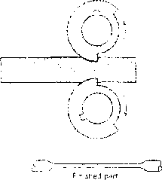

Figure 11: Principle of roll forging .

* **Precision forging (Net Shape Forming)**

Precision forging is employed to obtain a part which is very near to its final dimension and that

requires little or no additional finishing operations. Aluminum and magnesium alloys are particularly suitable for precision forging because of their low forging load and temperature requirments.

Parts formed is close to the final desired dimensions.

Steels and other alloys are more difficult to precision forge.

Good points are less machining involved and part is closer to final shape.

Tube

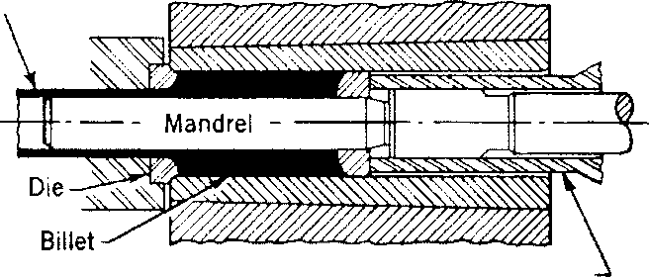

Press stem

Figure 14: Extruding a large tube from a heated billet.

**Hydrostatic Extrusion**

**■ Tube extrusion**

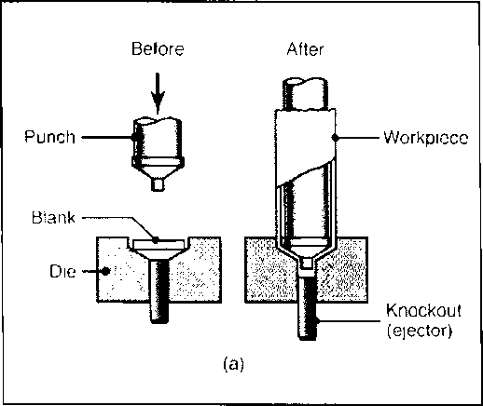

* Impact extrusion

*Figure 13: Impact extrusion of a collapsible tube by the Hooker process.*

The billet is smaller in diameter that the chamber, which is filled with a fluid, and the pressure is transmitted to the billet by a ram.

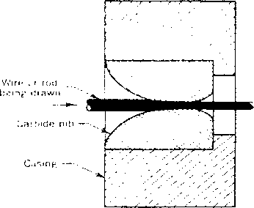

Figure 18: Section through a die used for drawing wires.

Metal spinning

Wire is made by cold drawing rod through one or more dies, similar to that shown in figure...

Metal spinning is the operation of shaping thin metal by pressing it against a form while it is rotating. The nature of the process limits it to symmetrical articles of circular cross section.

* A circular sheet metal is held against a rotating mandrel where the tool deforms and shapes it over the mandrel.
* Tooling costs are low and economical for relatively small production runs only.

*Figurel9 : Metal spinning operation*

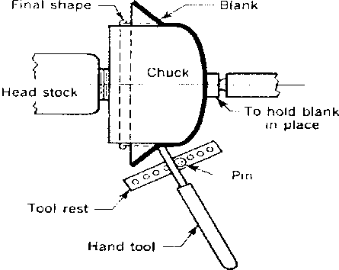

* For high production rates

Pressure pad

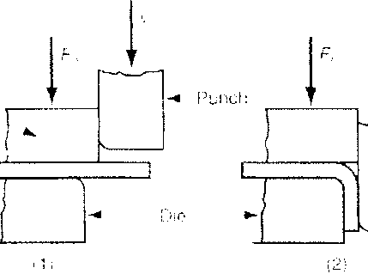

*Figure22 : edge bending process*

* Pressure pad required
* Dies are more complicated and costly

**Roll bending**

Bending of a metal sheet or plate into particular curvature is commonly performed by roll bending. It is also known as roll forming. The process consists of passing the metal sheet through a series of three rolls of equal diameter, two of them are fixed in a particular position and the third one is adjustable, which controls the degree of curvature.

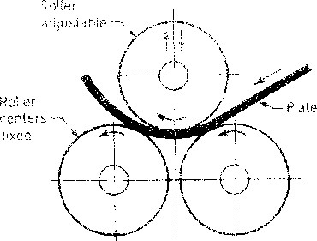

Figure 23 : Plate-bending roils

Strip (scrap)



Part



Blank (part)



(b)

Figure 26: (a) Blanking and (b) Punching

**Deep drawing**

Tube or rod drawing is essentially different from deep drawing, in which sheet metal is given hollow shapes. Deep drawing is also known as cup or radial drawing because of its ability to produce cup shaped device.

* Flat sheet-metal blank is pressed, using punch, into the die cavity.
* Bank is held in place with a blank holder under a certain force.

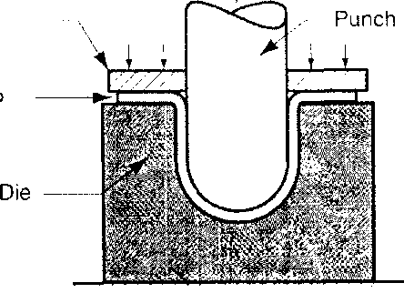

I:

*Figure27 : deep drawing process*

Blank holder

Work

(b)

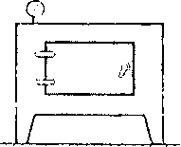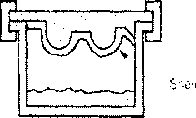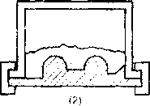

She'is

Dump

box

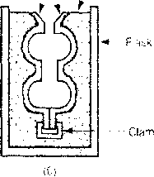

Metal

shot

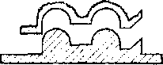

(5)

(*7*)

Casting process in which the mold is a thin shell of sand held together by  
thermosetting resin binder.

**Steps in shell-molding:**

1. a match-plate or cope-and-drag metal pattern is heated and placed over  
   a box containing sand mixed with thermosetting resin.
2. box is inverted so that sand and resin fall onto the hot pattern, causing a  
   layer of the mixture to partially cure on the surface to form a hard shell;
3. box is repositioned so that loose uncured particles drop away;
4. sand shell is heated in oven for several minutes to complete curing;
5. shell mold is stripped from the pattern;
6. two halves of the shell mold are assembled, supported by sand or metal  
   shot in a box, and pouring is accomplished;
7. the finished casting with sprue removed.

Healed

patlern

ra.

Sand

with

resri

hinder

0)



Fig ure 1.17 Steps of Exp^ttd^ripolyst&eepe casting process Advantages of shell molding:

* Smoother cavity surface permits easier flow of molten metal and better surface finish
* Good dimensional accuracy - machining often not required
* Less cracks in casting Disadvantages:
* metal pattern costly -design must include gate/runner
* large amount of expensive binding resin required
* Part size limited

This process uses wax patterns assembled in tree forms on a runner. The completed assembly is coated with ceramic slurry, allowed to dry and then heated to melt out the wax leaving a ceramic mould into which the molten alloy is poured. It is a precision casting process - capable of producing castings of high accuracy and intricate detail

Steps in investment casting:

1. wax patterns are produced,
2. several patterns are attached to a sprue to form a pattern tree
3. the pattern tree is coated with a thin layer of refractory material,
4. the full mold is formed by covering the coated tree with sufficient refractory material to make it rigid
5. the mold is held in an inverted position and heated to melt the wax and permit it to drip out of the cavity,
6. the mold is preheated to a high temperature, the molten metal is poured, and it solidifies
7. the mold is broken away from the finished casting and the parts are senarated from the some

Figurel.19 Steps of investment casting casting process

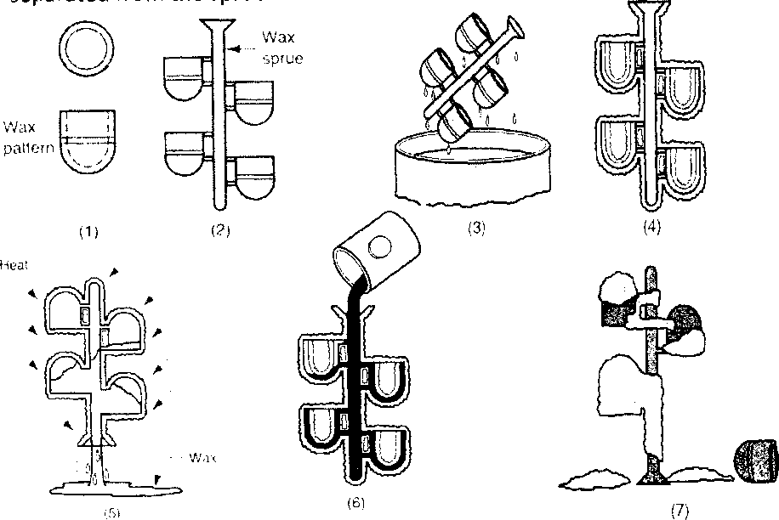

**Advantages and Limitations of permanent mold casting:**

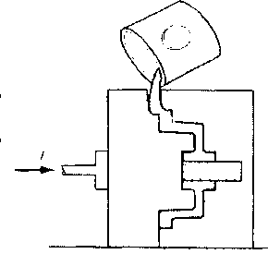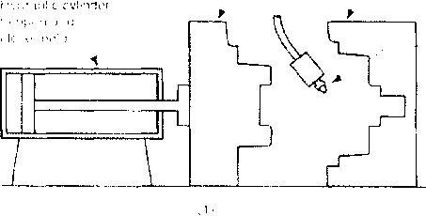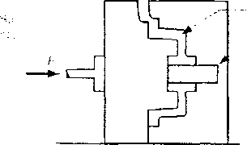

Figure 1.20 Steps in permanent mold casting

**Advantages:**

* Good dimensional control
* Excellent surface finish and grain structure.
* Superior mechanical properties.
* Repeated use of molds.
* Rapid production rate with low scrap loss
* uniform castings with high dimensional accuracy.

**Limitations:**

* Generally limited to metals of low melting temperature alloys
* High cost of mold
* Generally limited to the production of somewhat small castings of simple exterior design

Die Casting

A permanent mold casting process in which molten metal is injected into mold cavity under high pressure.

* Pressure is maintained during solidification, then mold is opened and part is removed
* Molds in this casting operation are called dies;
* Use of high pressure to force metal into die cavity is what distinguishes this from other permanent mold processes
* Tungsten and molybdenum dies used to die cast steel and cast iron

39

Stationary die halt Figure 1.22 Cold Chamber machines

Advantages of Die Casting

* Excellent dimensional accuracy.
* Excellent smooth surface finish.
* Suitable for relatively low melting point metals
* High production rates.
* Thinner walls can be cast
* Cost of castings is relatively low with high volumes.
* No pattern, Long mold life Disadvantages of Die Casting
* Limits on the size of castings - most suitable for small castings...
* Equipment and die costs are high, only suitable for mass production
* limited to low-melting point alloys

• Copper-base Alloys

Die castings of brass and bronze present more problems in pressure casting because of their high casting temperatures . Heat-resisting alloy steel dies are used to reduce their rapid deterioration. Cost of brass die castings is, therefore, comparatively higher.

Difficulties of rapid oxidation of steel dies due to high temperatures involved have been largely overcome.

by improvement in die metals and

by casting at as low a temperature as possible.

1. Quality of the cast product is better

   No need to have slabbing/blooming or billet mill as required when ingot casting is used.

   Higher extent of automation is possible

   Width of the slab can be adjusted with the downstream strip mill.

   Continuously cast products show less segregation.

   Hot direct charging of the cast product for rolling is possible which leads to energy saving.

   How casting is done continuously?

   The essential components of a continuous casting machine are tundish, water cooled mold, water spray and torch cutters. Tundish, mold and water spray are arranged such that molten stream is poured from tundish to mold and solidified strand (billet/bloom/billet) is produced continuously. The required length of the strand is cut by torch cutter. In figure 32.1, the arrangement of tundish, mold and water spray is shown.
2. Ultrasonic inspection,

   * internal defects can be detected by introducing high -frequency sound waves in to the metal casting.
   * internal flaws and locations can be determined by analyzing reflected sound waves

  
3. Cold Working:

   Deformation performed at or slightly above room ambient temperature - no heating required

   Great force are required

   Less reactive environment

   Better surface finish

   Better dimensional control

   Improved mechanical properties