Republic of Iraq
Ministry of Higher Education and Scientific Research
UNIVERSITY OF TECHNOLOGY
Building and Construction Engineering Department

Experimental Study on the Behavior of Strip Contaminated Sand
By:

Bassma Ali Dawood
Supervised by:
Prof. Dr. Mohammed Y. Fattah Lec. Mohammed F. Aswad
2014 1435
Abstract:
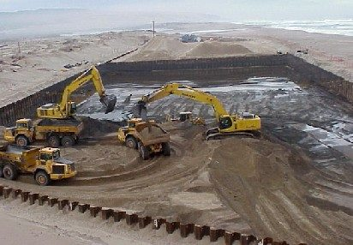
This research presents the results of a series of model tests carried out on both clean sand and oil-contaminated sand loaded with a rigid strip footing. The objectives of this study are to determine the influence of oil-contaminated sand on the bearing capacity characteristics and the settlement of the footing. Contaminated sand layers were prepared by mixing the sand with an oil content of 10-20% with respect to dry soil to match the field conditions. The investigations are carried out by varying the depth and the length of the contaminated sand layer and the type of oil contamination. It is shown that the load-settlement behavior and ultimate bearing capacity of the footing can be drastically reduced by oil contamination. The bearing capacity is decreased and the settlement of the footing is increased with increasing the depth and the length of the contaminated sand layer. A circular footing 65mm in diameter and 10mm thick was rested on sandy soil. The sand was contaminated with gasoline by different percents by weight (10%, 15% and 20%). The depth of contaminated soil was varied between D/2 and D. It was concluded that:
- The bearing capacity of the footing decreases considerably when the underneath sand contaminated with gasoline.
- For the depth of contaminate is D/2, the decrease in bearing capacity was found to be (65.6 %), (59.4 %) and (51.3 %) for percent of contaminate in the sand (10%), (15%) and (20%) respectively.
- For the depth of contaminate is D, the decrease in bearing capacity was found to be (70 %), (78.7 %) and (33.1 %) for percent of contaminate in the sand (10%), (15%) and (20%) respectively.
- For the same percent of contaminate, the bearing capacity is decreased by about (5 –20) % when the depth of contamination is increased from D/2 to D.

